# DAEN 690

# Migration Patterns

# **Migration Patterns – Identifying metropolitan areas that will experience growth and development**

Authors: Myra D’Souza, Swathi Toyaja Chepyala, Snigdha Cheekoty, Meghana Tunga, William Nguyen

# Project Definition:

A trend is beginning to emerge in many metropolitan areas in the United States. Many cities and metropolitan areas are experiencing tremendous growth in net migration as people from other cities and states are attracted by the inclusive economic[1] growth and development. Driven by the inclusive economic growth model and culture, the metropolitan economy attracts high-skilled workers there by drawing in migration of all socio-economic levels to support remaining sectors of the economy by increasing demand of services jobs. Low-skilled and middle-skilled workers can have social mobility with access to education and re-training programs. This culture also encourages entrepreneurial opportunities and small businesses like start-ups. It attracts high-tech businesses looking for cheaper and high-skilled labor coming graduating from high-ranked universities in these cities. Businesses invest in the infrastructure of the cities and contribute to economic growth by creating more jobs. The metropolitan economy can compete with global cities with less dependence on Federal and State government support, aids and grants.

Historically, Americans have always been highly mobile travelling to unexplored areas looking for safer conditions and better opportunities. During the industrial expansion after the civil war, Americans started to move from rural areas to urban cities. The cities grew in population and size. Part of the overall growth was due to the mass immigration to the United States that took place during the first two decades of the twentieth century. In the late 1870, only two American cities had a population over 500,000 which later increased to six by 1900 three of them being New York, Chicago and Philadelphia. The rise of railroads was also the major reason for the migration to metro areas apart from industrialization. Like how Atlanta had a rapid influx of population, Los Angeles also became one of the top areas due to Southern Pacific and Santa Fe railroads. Although birth rate declined in the United States in the late nineteenth century, urban migrations from farms and small towns to the larger cities along with overseas migration lead to the rise of many metropolitan areas. (Green, 2014) We see evidence of growing cities even today. Detroit, Michigan used to be known as the automobile capital of the world and experienced rapid growth in the 20th century. Meanwhile, neighboring town of Ann Arbor 30 miles away became the main campus of the University of Michigan and grew in population. In the 2010 Census Bureau population survey considered the city of Ann Arbor as well as Detroit Michigan to be a combined statistical metropolitan area (MSA) with an area coverage of 3,913 sq mi. US MSAs that are global leaders in today world are New York-Newark-Jersey City, NY-NJ-PA MSA, Los Angeles-Long Beach-Anaheim, CA MSA and Chicago-Naperville-Elgin, IL-IN-WI MSA with population estimates of 20 million, 13 million and 9 million, respectively and are in the top 5 for cities with the largest GDP in the world.

What makes a metropolitan successful? While GDP is one factor that is a result of a successful MSA there are many factors that cause an influx in migration, create jobs and boost the local economy. Some cities that have reinvented themselves while reaching for success. An example of successful growth is Pittsburg. In the 1980s and 1990s, Pittsburg suffered a large radiation leak that left the city unlivable and in dire economic condition. Furthermore, manufacturing jobs were vanishing as steel factories shutdown. Today it is the robotics capital of the world. Universities like Carnegie Mellon are leading the research in the Robotics field and other colleges offer 2-year Robotics Degree programs to train displaced workers. Pittsburg used robots with sensors to collect information and clean up the radiation leak. The city attracts more high-skilled workers in the 25-45 age demographic but overall its population growth is stagnant. It is one of the few pioneer cities to have driverless cars and one of the top 20 cities under consideration by Amazon looking to base its second headquarters. “Pittsburg’s position in the global economy stems from an understanding of the drivers of modern competitiveness and leaders’ and citizens willingness to adapt to new economic realities.” (Katz, 2018, p. 59) While the GDP for other metro areas like Austin, Texas are some of the fastest growing since 2010 at 20% and 18%, respectively. In the last 8 years, Austin has crossed the 2-million population mark to be considered a large metropolitan and it ranked second in highest GDP among large metropolitans after San-Francisco. For fastest growing in the mid-size metropolitan areas, Provo Utem, Utah ranked first. It had a GDP of 6.1% in 2016 and outpaced San Jose, CA and Raleigh, NC. In small metropolitans with less than 250,000 people, Lake Charles, LA and Bend-Redmond, OR was the fastest growing with a GDP increase of 8.1%. While neighboring town of Lafayette, LA dependent on the oil industry, decreased in growth by 11%. (FIGURE 5)

The scope of our research is to focus on identifying the metropolitan areas that are likely to experience an increase in labor force growth from having a competitive economy and innovative culture. We will build a model using machine learning techniques to understand the importance of various attributes that make a metropolitan successful. The model will be used to identify metropolitan areas that have the right factors in place that make it attractive for high-skilled labor to move there and companies to want to invest in setting up their offices in these areas. We will study various factors and use the findings from researchers in the field of labor economics, metropolitan policy and economic development. The ‘Use Story’ section of this paper will provide the various real-world applications for this model. The ‘Analysis’ section of this paper list the various attributes used in the study and how we built our model to identify upcoming metropolitan areas. The ‘Datasets’ section of this paper will provide an understanding of all the datasets used and the sources used to get the data. We will also cover feature engineering and data cleaning techniques used in our dataset.

# Project Scope:

Our data has shown that certain metropolitan areas have been very successful in having an inclusive economy[2] with lower than average unemployment rates and an increasing high-skilled labor force. Inclusive economic growth explained by the Brookings Institution Metropolitan Policy Program, fuels job growth among high-skilled workers and low-skilled workers and provide a means for social mobility. High-tech firms like Amazon are drawn to these areas because of the high-skilled labor available and high-skilled workers are attracted by the inclusive economy, high-tech jobs, and innovation driving the metropolitan growth. With high-skilled worker mobility high from one metropolitan areas to another, we consider a mix of factors that drive innovation like research spillover from universities and startup growth. We also consider more traditional factors like crime rates and housing prices as indicators for attracting high-skilled labor and in turn high-tech companies. High-skilled migration also creates low-skilled worker demand, but this could leave the middle-skilled workers displaced and more likely to move out of metropolitans. David Autor, MIT Labor Economist argues that automation has made middle-class jobs disappear but if carefully mitigated by encouraging education and retraining skills, it could be an opportunity for social mobility in a metropolitan area. Our study will examine the importance of various factors that contribute to the rise of a successful metropolitan area and we will build a model using those factors to identify other metropolitan areas that would be most attractive to migrants for the purposes of better job opportunities and social mobility.

# Primary User Story (-ies):

Our model can be used in various ways. It exists to bring awareness to emerging metropolitan areas that are in their early stages of growth. As a real-estate developer, the model would help identify areas to invest and those areas that will experience a rise of home prices to accommodate the growing demand. According to a study done by the National Bureau of Economic Research in 2000, between 1950 and 2000, the price of housing grew by an inflation-adjusted annual rate of 2.2 to 3.5 percent in the ten U.S. metropolitan areas with the highest rates of growth, and by 0.5 to 1.1 percent in the ten U.S. metropolitan areas with the lowest rates of growth. Over the same time-period, the number of families living in U.S. metropolitan areas doubled and the number of families with inflation-adjusted incomes above $140,000 in 2000 dollars grew more than eight-fold. (Gorman, 2018) When stocks of homes are limited in growing cities, new developments are very profitable.

As a company looking for high-skilled laborforce at lower wages, the model would provide a good read on migration trends in various metropolitans and those that may have high-ranked universities in close proximity. This type of analysis is relevant for companies like Amazon deciding on where to build its second headquarters. Amazon, based in Seattle, WA has been searching for its second headquarters in a metro area and plans to employ 50,000 local employees. They are seeking high-skilled labor, proximity to universities and quality of life. They have narrowed their search from 200 metros to a list of 20 finalist. Local governments have offered many tax breaks and other incentives to be selected as Amazon’s HQ because Amazon has also agreed to investing in the city’s infrastructure and its indirect effects are estimated to create more than 50,000 jobs and $40 billion in investment in the local economy. (Amazon, 2018)

# Definition of Terms:

Metropolitan area(MSA) - The OMB defines a Metropolitan Statistical Area as one or more adjacent counties or county equivalents that have at least one urban core area of at least 50,000 population, plus adjacent territory that has a high degree of social and economic integration with the core as measured by commuting ties.

Unemployment rate - people who are jobless, actively seeking work, and available to take a job, as discussed above. The unemployment rate is the number of unemployed as a percentage of the labor force (the sum of the employed and unemployed)

Labor force participation: The labor force is made up of the employed and the unemployed. The labor force participation rate. This measure is the number of people in the labor force as a percentage of the civilian noninstitutional population 16 years old and over. In other words, it is the percentage of the population that is either working or actively seeking work.

Gross Domestic Product by Metropolitan - is the value of the goods and services produced by the metropolitan’s economy less the value of the goods and services used up in production.

Inclusive economy: mix of jobs in high-skilled sectors as well as low-skilled jobs across all races and ethnicities. Inclusive economies head innovation with a healthy entrepreneurial presence of younger companies and more established companies

High-skilled workers: are typically professionals who have a degree in their field — often in science, technology, engineering, or medicine

Low-skilled workers - those who work in blue-collar jobs, including construction, hospitality, maintenance, and agriculture

High-tech Jobs - Jobs available in the high-technology industry and include various types of engineers, IT workers, scientists, postsecondary teachers, and managers of these workers. High-tech jobs can also exist in the manufacturing industry, although this has been declining. “High-tech jobs contribute to 12% of all jobs available but produce 23% of total output”.

# Dataset Overview:

The large part of our project focused on data conditioning and feature extraction. Initially, we were hoping to obtain data for all factors identified and perform a time-series analysis. However, due to availability of data specific to metropolitan areas, we decided to perform feature extraction to derive a meaningful way on measuring trends when very little historical data is available. For example, the US Census Bureau data tracked by metropolitan areas changes every 10 years to add new MSAs and remove some MSAs that no longer qualify as a metropolitan because the population is below the required limit. Other data sources like Bureau of Economic Analysis started measuring GDP by metropolitan area in 2010.

# Innovation Index 2.0 from StatAmerica

Innovation index is a blended index that considers six categories: Human Capital and Knowledge Creation Index, Business Dynamics Index, Business Profile Index, Employment and Productivity Index, Economic Well-Being Index and Social Capital. The index was an improvement from a previous index and added 50 more measures. Data is available at the MSA level unlike most metrics that report in state and county levels. The dataset is publicly available and reported in raw index values, ranked index and median index for each MSA. The dataset also includes a headline index – which is a collection of weighted measures.

In the dataset, we had 78 measures for 380 MSAs. For the 78 measures, we had a raw index value, a ranked index against other MSAs and a median for all the MSAs. There were two metropolitan areas that were missing values. We decided to remove the median measure as it would not have helped our model with all MSAs having the same value. All index values in the set of measures for the Innovation Index dataset was normalized and were numeric. There were some values that had ‘zeros’ because data was unobtainable.

After PCA and correlation analysis, we kept the following measures for our model:

Human Capital and Knowledge Creation Index – “Human capital and knowledge creation affect the degree to which a county’s labor force is able to engage in innovative activities. Growth in a county’s workforce ages 25 to 44 signifies that a county is becoming increasingly attractive to younger (arguably more energetic) workers—those more likely to contribute to innovation.” (StatAmerica, 2018)

The core factors to measure Human Capital and Knowledge are education attainment, knowledge creation and technology diffusion and STEM education and Occupations

* Educational Attainment – measures the ratio of people in the metropolitan with some college, Associate Degree, Bachelor’s Degree and Graduate Degree
* Knowledge Creation and Technology Diffusion – measures volume of patents and types of patents coming out of a region.
* STEM Education and Occupations – measures the number of graduates in the STEM field in a metropolitan area.

Business Dynamics Index – measures the number of business formed in a region as well as the dynamics of those businesses and how many jobs they are adding to the local economy. Business dynamics also measures labor churn which is the opportunity of a worker moving to a higher-wage job in the situation where the lower wage job is now automated or outsourced.

Venture Capital Dollar monitors the trend of investment by venture capital financing. The higher the measure the easier it would be to find financing for a start-up company.

Venture Capital Count measures the number of IPOs in the region and the ratio of the total number of venture capital deals with the GDP.

Business Profile Index – This index measures how attractive the region is to foreign direct investments coming in and created jobs and investments.

Connectivity measures the resources in place for entrepreneurs to be able to gain information to stay innovative and competitive in their business.

# Labor Force and Unemployment Dataset

We obtained the labor force and unemployment dataset from the Bureau of Labor Statistics. The collection of data for MSAs started in 2001. Persons in the labor force are those individuals that are employed and unemployed. They are not retired, students, children and actively looking for a job if unemployed. This dataset was complete and accurate. The source of the dataset, Bureau of Labor Statistics is reliable. For the Labor Force data, we were more interested in recent changes in in labor force participation in each metro area. We calculated a percent change for labor force,

Where is the Labor Force population for 2016 and is the Labor Force population for 2010.

We used a mean unemployment rate given by,

where represents the year 2010 and is the unemployment rate.

# Crime Dataset

The crime data for the migration pattern analysis is taken from the Federal Bureau of Investigation’s Uniform Crime Reporting (UCR) Program. The dataset consists of 12 fields including the metropolitan areas and the counties associated with each metropolitan area. From this dataset, we considered the violent crime field which is composed of four offences: murder and nonnegligent manslaughter, rape, robbery, and aggravated assault.

The data collected in this dataset lists only the serious offense. They follow a Hierarchy rule where crimes are sorted in a descending order starting with murder and nonnegligent manslaughter, rape, robbery, and aggravated assault, followed by the property crimes of burglary, larceny-theft, and motor vehicle theft.

The dataset contains data from the year 2000 to 2016. Since we are focusing on the migration pattern solely in United States, we didn’t consider the Puerto Rico region. The dataset also had a huge number of missing values as it is not required for local law-enforcement agencies to submit their data to the federal level. Due to this, we took a mean value of each metro area from the year 2010 to 2016 for 383 metropolitan areas.

We used a mean crime rate given by,

where represents the year 2010 and is the crime rate.

# GDP Dataset

The Gross Domestic Product data was taken from Bureau of Economic Analysis. The GDP rate field was chosen from this dataset. GDP by metropolitan area is derived as the sum of the GDP originating in all the industries in the metropolitan area.

The dataset consists of chained-dollar values, percentage change and the rank fields. The real GDP by metropolitan area captures the differences across metropolitan areas that reflect the relative differences in the mix of goods and services that the areas produce

The dataset contains data from the year 2002 to 2016. The dataset didn’t require much of data conditioning as the dataset was clean and there were no null or missing values.

# Housing dataset

# The home price index (HPI) data was taken from the Federal Housing Finance Agency. It is the measure of movement of single family house price. It measures the average price change in repeat sales or refinancing on the same properties. This data is obtained by repeatedly reviewing mortgage transactions on single-family properties which has been purchased or securitized by Fannie Mae or Freddie Mac.

# The dataset consists of the year, metropolitan area, quarter, purchase index and the percentage change over the four quarters as the home price is calculated on a quarterly basis. The dataset contains data from the year 1986 to 2016. The home price of each metropolitan area for a given year is calculated by adding all the quarterly values for each metropolitan area. As we are focusing mainly on the data from the year 2000, we consider only those values.

# University dataset

Some of the best universities in the world are in major metropolitan areas. Universities spend a lot of time and money on research and usually produce high-skilled labor. New York City, for example, is surrounded by 13 of the most ranked universities. “The increasing growth of colleges and universities improves the quality of the labor force and stimulates knowledge-based industries which in turn attracts more students and better educated employees” (Isabel V. Sawhill)

The university dataset was obtained from US News & World for the year 2017. Historical data was not readily available from this data source. The methodology behind building the ranking consist of Graduation rates, reputation, faculty resources, student selectivity, financial resources and alumni.

We obtained the top 150 overall ranked universities in the country. We then looked at a 30-mile radius for each metropolitan and determined the frequency of high ranked universities that were in that 30-mile radius. For metropolitans that had more than one high-ranked university, we took the mean of the rankings to determine the university ranking for each metropolitan. For the university data, we have a ranking variable and frequency variable.

# Analytics and Algorithms

# Analytics

Our approach to analytics for this project was to understand each feature and look for patterns in trends using descriptive statistical methods. Since our data involved geographical regions in the US, we produced at spatio-temporal analysis graphs. We were able to see patterns of similarities and differences in MSAs that were geographically close to each other and belonged to a region like Northeast area or Southern states.

We looked at 4 important features from the innovation core indexes in spatio-temporal graphs. The Human Capital and Knowledge graph shows strong presence in the Northeast part of the country as well as some California regions but weaker presence in the middle of the country with the exception of Boulder. Since human capital measures population of those able to work, it is not surprising that the most populated MSAs in the country would have a higher human capital and knowledge index. These MSAs also have high presence of tech companies and knowledge creation and STEM education through universities. The top 3 MSAs in this region was San Francisco, New York and Boulder. The Economic Dynamic graph in FIGURE 3 shows a good distribution all around the country with some exceptions in the State of Arizona. Economic dynamic index measures business created and those businesses that create more local jobs. Top 3 MSAs for this index was San Jose, Austin, Boulder. There were also smaller pockets of metropolitans that were not doing too well in this index. Employment Productivity graph in FIGURE 4, looks at jobs created in the high-tech industry and industry performance. We find that parts of the Northeast and most regions in Florida are not doing too well in this measure. The top 3 were Fargo, ND, Midland, TX, Hinesville, GA. Finally, for the Economic Well Being index in FIGURE 4, Midwestern metros performed better as well as some Northeast metros. The top 3 metros were Bismark, ND, Fargo, ND, Casper WY. This index measures social factors like poverty rate and change in personal income.

In FIGURE 5, we analyzed metro areas with a high concentration on ranked metros with 30 miles. Our graph shows that the successful metros (marked in dark blue) had more ranked universities than some of the less successful metros (marked din grey). The top regions were Chicago, Los Angeles, Dallas and Pittsburgh areas. Housing prices were also rising at a faster rate in some metropolitan areas as demand for housing in those areas rose. In FIGURE 6, we looked at the Housing Price index changes from 2010 – 2016. Expectedly, the housing prices of some metropolitan areas in the state of California have grown significantly. Some unexpected areas were Midland,TX and Bismark, ND.

# Algorithms

# Data-Preprocessing

We followed feature selection principals and data pre-processing methods. We decided to try out multiple machine learning algorithms to see which model would fit best for our problem. Our code was written in Python using Jupyter Notebooks. We used many data science libraries like numpy, pandas, scikit-learn and matplotlib. Our initial dataset was not very large with just 383 observations and 120 variables. We removed any time-series data points and used aggregated features that was created. For example, for the laborforce data points from 2010-2016, we took the net change in percentage from 2010 to 2016. For those time-series data points that had missing values, we took an average of the data point. For example, we used the mean of the unemployment rate from time-period of 2010-2016.

We performed Principal Component Analysis to summarize our data points illustrated in FIGURE 10. We discarded any variables that were redundant and looked at the correlation of the variables in FIGURE 11. Our final dataset contained 28 variables. Our dataset was unbalanced with the target variable counts of 268 for not successful MSAs and 111 successful MSAs. We used a resampling method to boost the observation count for the minority class and made the target class represented equally in the dataset. An unbalanced dataset could introduce bias toward the majority class when training a model. Since we did not have any categorical values, we did not need to encode our data points. Our dataset was split 60% for training and 40% for test. Our target variable was also balance in the training dataset.

# Build Models

We studied six different models and compared the performance to each other using ROC curve. The following are the results of our models:

Logistic Regression

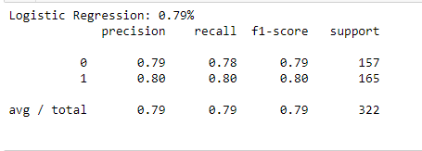

Support Vector Machine

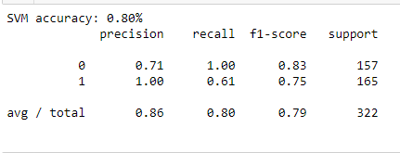

Multi-layer Perceptron (MLP)

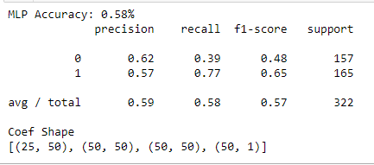

Random Forest

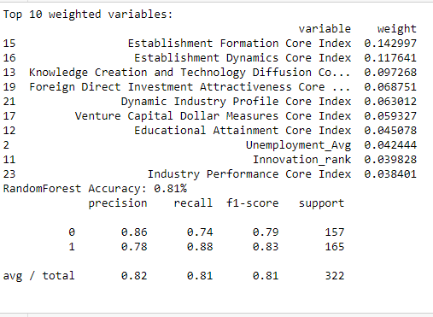

Decision Tree

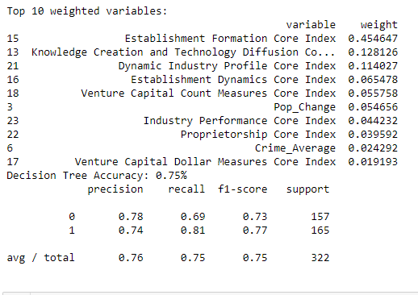

Adaboost

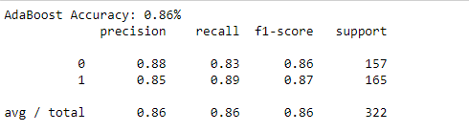

Model Performance/ ROC



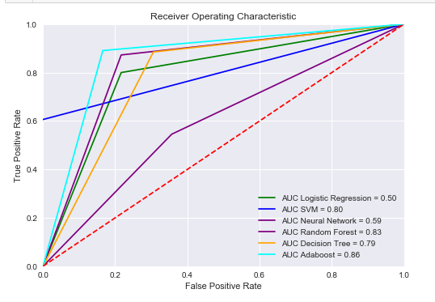

FIGURE 14

# Evaluation

The least favorable models were the logistic regression and neural network. The best performing models were the ensemble models of Random Forest and Adaboost with accuracies of 83% and 86%. Beyond the measure of accuracy, both of the model optimize the variance-bias tradeoff or the overfitting/underfitting problem. Random Forest, a type of bagging method produces a low bias but high variance model while boosting models like Adaboost have high biased and low variance. To mitigate this problem, we use Adaboost model with a decision tree classifier. The combination of these two models gives us an optimal bias/variance tradeoff. The ROC curve in FIGURE 14 shows the comparison of all models by plotting the true positive rates and false positive rates for each model at different thresholds. The best performing model will have the highest Area Under the Curve (AUC). The best performing model was the Adaboost model with AUC of 86%.

# Visualization/Findings/Results

**Figure 1**

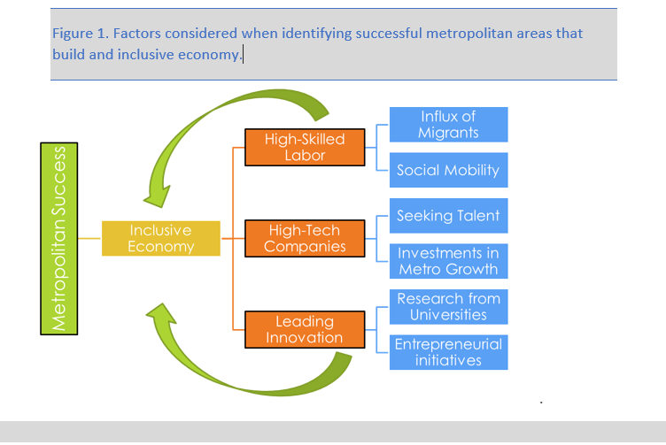

**Figure 2**

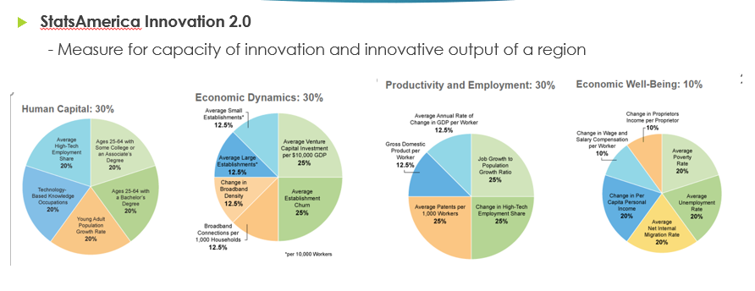

Source: <https://www.statsamerica.org/innovation/reports/sections2/C.pdf>

**Figure 3 – Metropolitan Examples by population levels**



**Figure 3 Innovation Core Index**

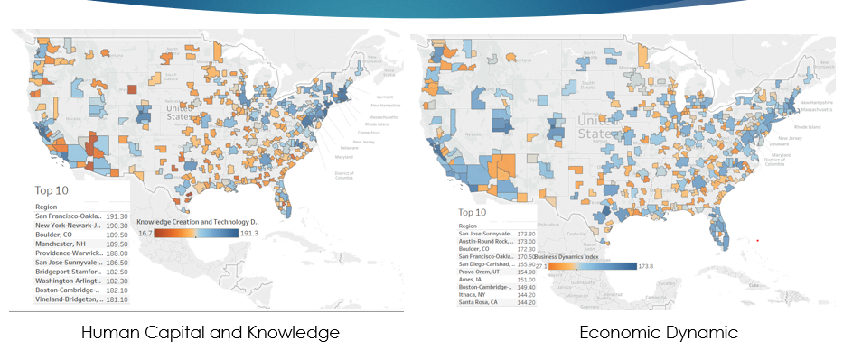

**Figure 4 Innovation Core Index**

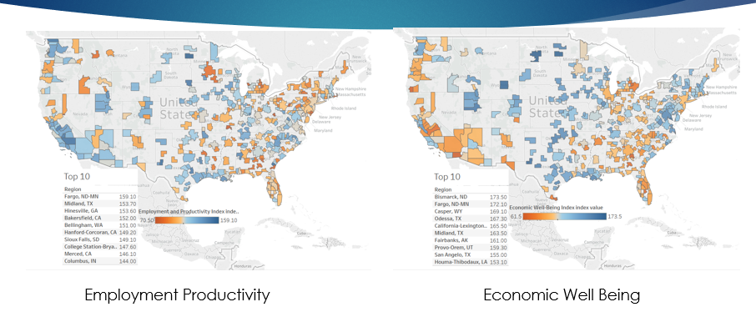

Figure 5 – Labor Force and GDP

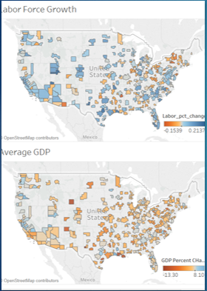

Figure 6 – University Dataset

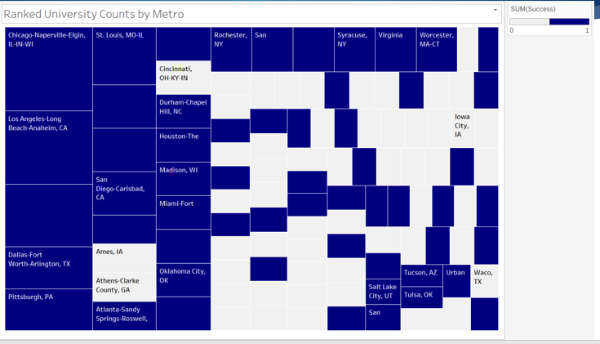

**Figure 7**

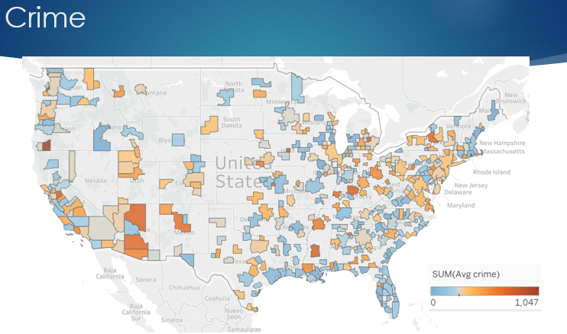

**Figure 8**

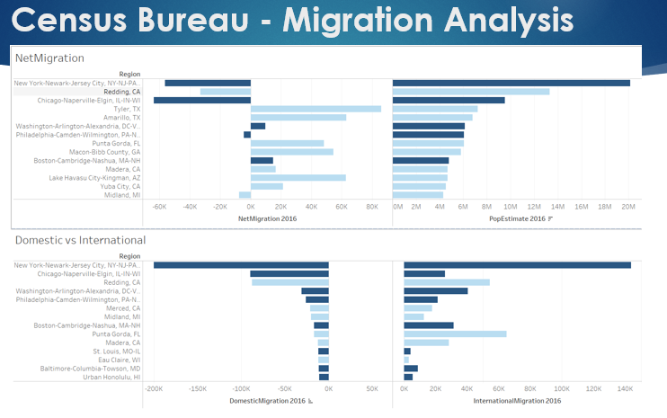

**Figure 9**

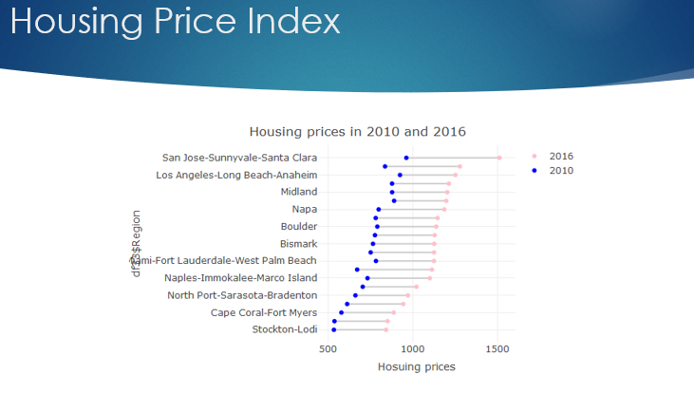

**Figure 10 – Principal Component Analysis**

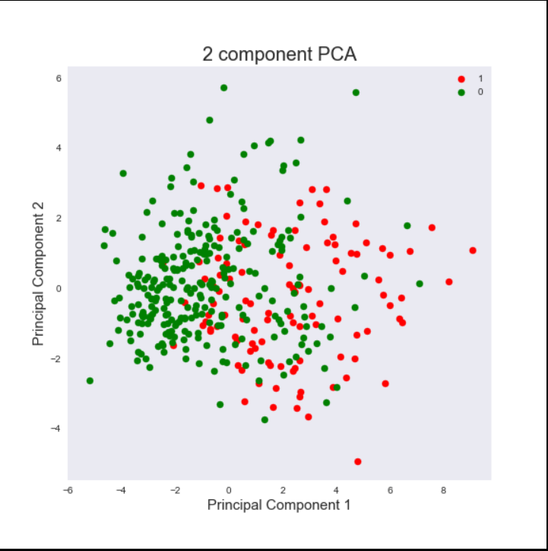

**Figure 11 – Correlation Matrix**

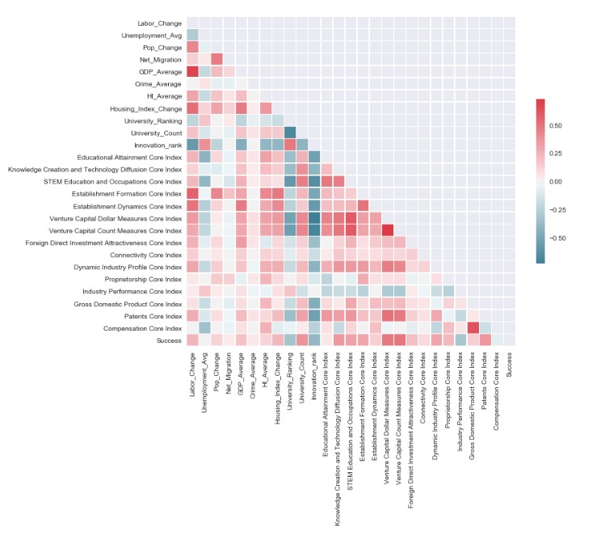

**Figure 12 – Balanced Dataset**

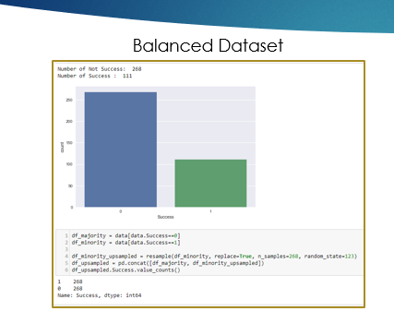

**Figure 13 – Next best metros from model**

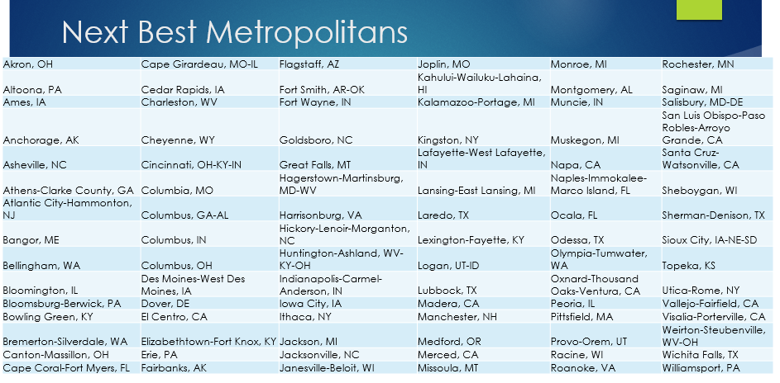

# Summary

Our research problem was to develop a model to predict which metro has the potential to grow and become successful by understanding the different factors involved in creating a successful metro. High-skilled workers are seeking better opportunities and moving to MSAs that have an inclusive economy and innovation culture. Bruce Katz of Brookings Institute explains that metros need to innovate and reform to grow and strengthen their local economy independent from the State and Federal level. These MSAs are attractive to high-tech companies seeking high-skilled labor. These MSAs are growing rapidly and creating more jobs of all skill level as well as producing more patents and research by having some of the top ranked universities in the region. Labor Economist, David Autor in his research concludes that migration amplifies local labor demand by as much as 15%. These MSAs have a good mix of large businesses and start-up smaller business that attract many venture capital financing.

In our study we built a predictive model based on significant factors that incorporate attributes that David Autor consider importance features like laborforce and GDP as well as other economic factors. Innovation is a huge part in the success of metropolitan areas and the innovation indexes from StatAmerica combined difference components that measure innovation in a region. We built multiple models to study which one had the best outcomes and evaluated the outcomes using accuracy as a measure and comparison of models using ROC curve. Adaboost model performed the best and results from our model identified MSAs that were going to see rapid growth. FIGURE 13 shows the metros identified to be the next best metropolitans.

# Future Work

The major part of our project was collecting and conditioning the data and finding significant factors that would identify a successful MSA. Going further, it would be beneficial to collect more data specific to metropolitan areas since not many agencies are reporting by metropolitans. Another consideration is to add more external data sources and identify other factors that were missed. Innovation index2.0 will be adding a 7th category for state context. This would include measures like education funding per pupil, Institutionally-Based Startups. Further analysis is needed on features and understanding the features in the specific domain. Reaching out to the researchers mentioned in the paper would be recommended. Finally, the model identified which metropolitan area would experience economic growth, however the next iteration of this project could focus on ranking metropolitan areas by the most likely to be successful and have the most growth.

# Appendix A

GitHub link - <https://github.com/SwathiToyaja/DAEN-Project>

# Appendix B – Project Risk

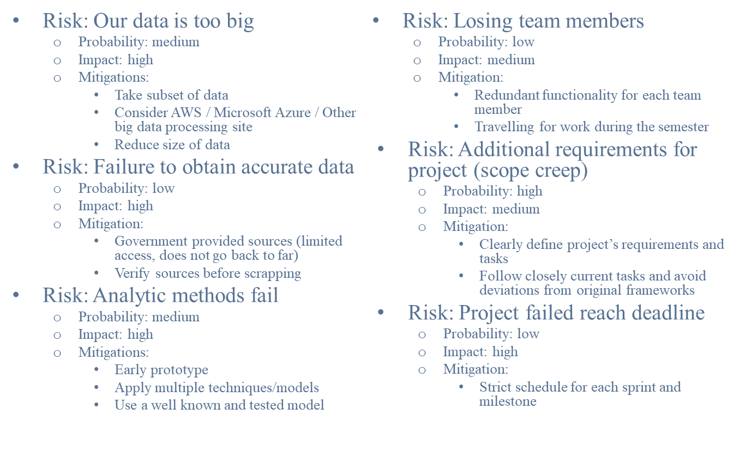

# Appendix C – Agile Development

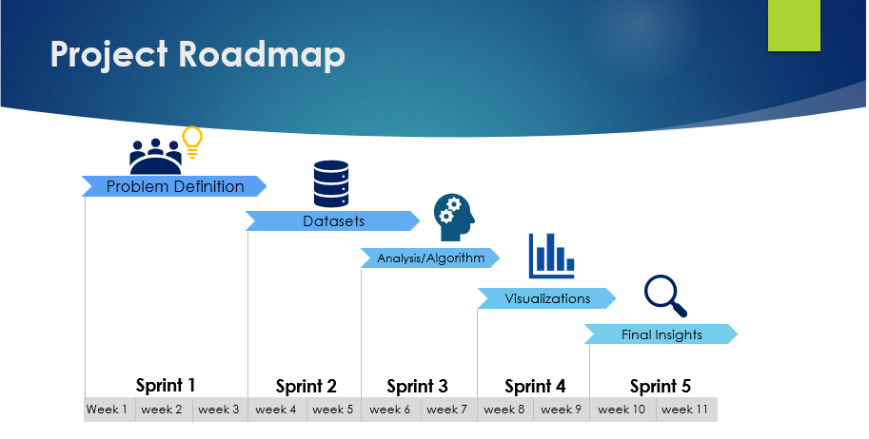

# References

Amazon. (2018, 05 05). Amazon HQ2 RFP. Seattle, WA, USA.

Gorman, L. (2018, 05 05). NBER - Why Do House Prices Rise Faster in Some Cities? Cambridge, MA, USA. Retrieved from http://www.nber.org/digest/mar07/w12355.html

Green, C. M. (2014). *The Rise of Urban America.* Routledge.

Isabel V. Sawhill, J. T. (n.d.). The Effects of Investing in Early Education on Economic Growth. Retrieved from https://www.brookings.edu/research/the-effects-of-investing-in-early-education-on-economic-growth/

Katz, B. (2018). *The New Localism.* 01: Brookings Institution Press.

StatAmerica. (2018, 05 05). Innovation Index. Retrieved from http://www.statsamerica.org/ii2/reports/Driving-Regional-Innovation.pdf

1. Inclusive economic growth is measured by a mix of jobs in high-skilled sectors as well as low-skilled jobs across all races and ethnicities. Inclusive economies head innovation with a healthy entrepreneurial presence of younger companies and more established companies. <https://www.brookings.edu/blog/the-avenue/2017/04/27/the-surprisingly-short-list-of-u-s-metro-areas-achieving-inclusive-economic-growth/>
2.